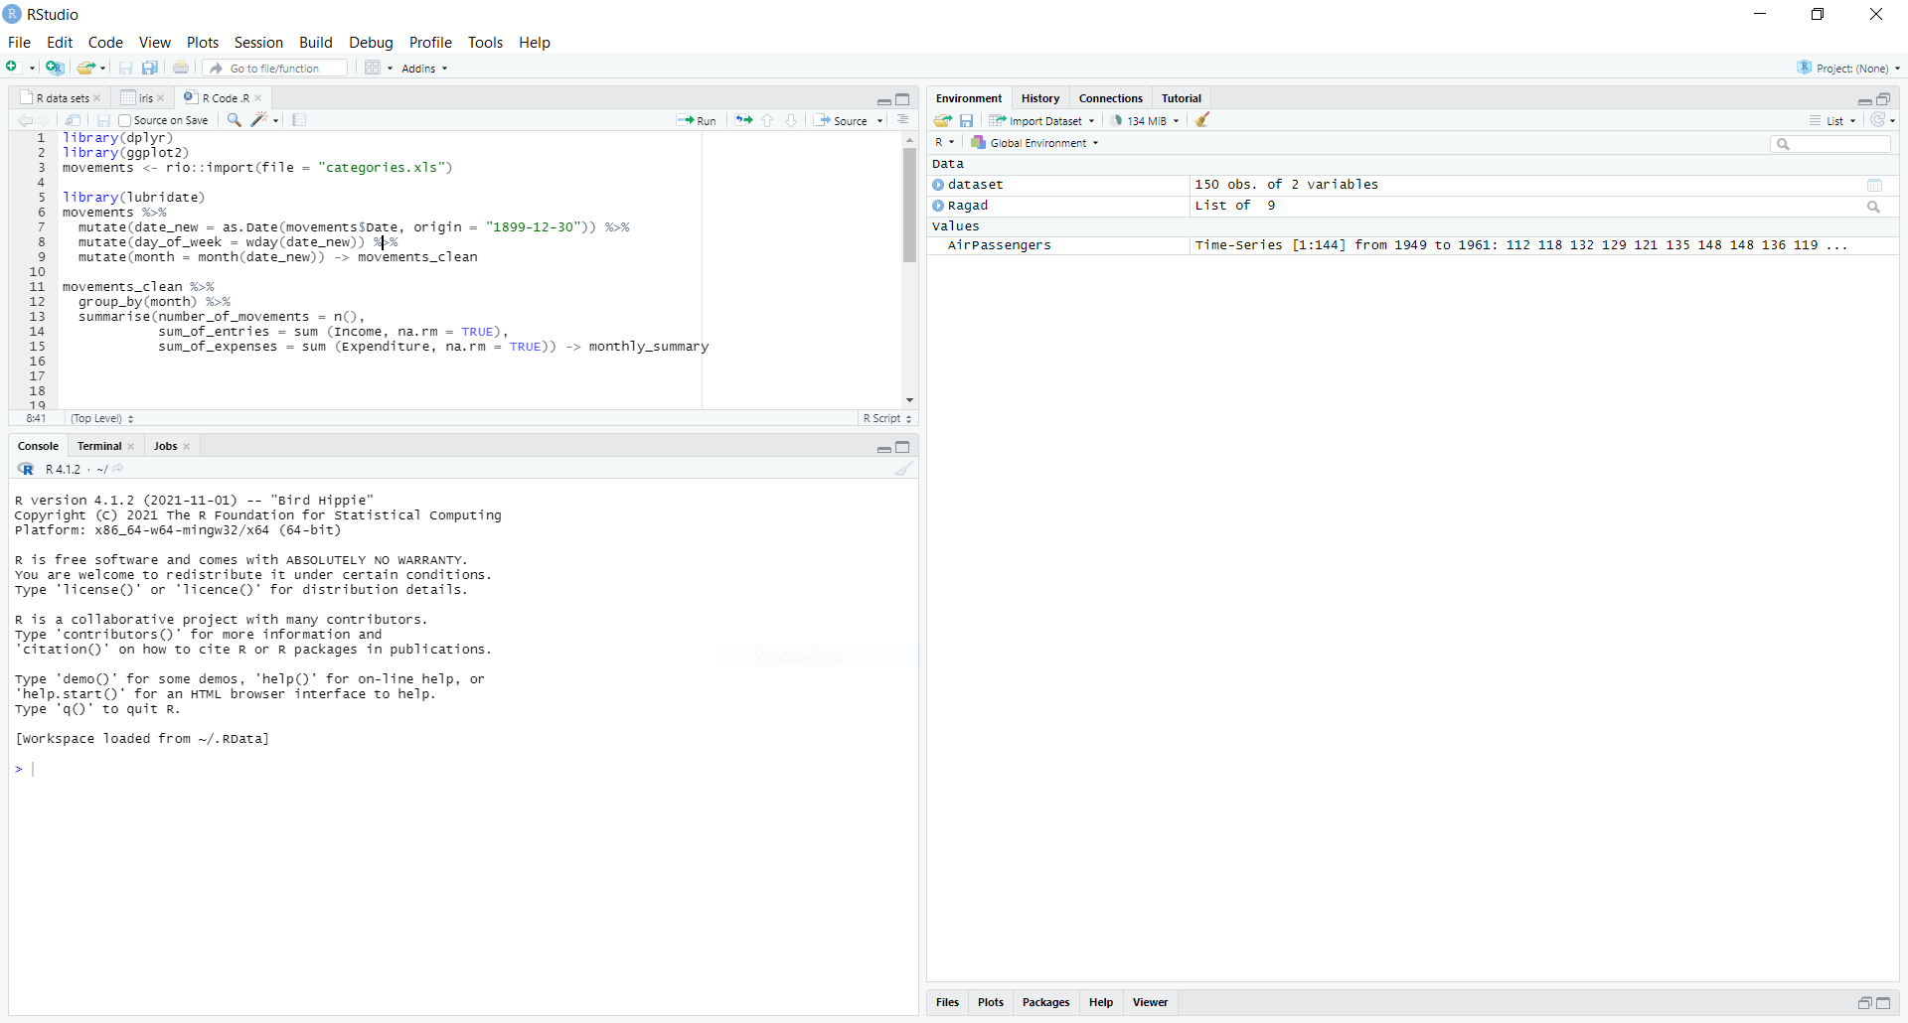

library(dplyr)

library(ggplot2)

movements <- rio::import(file = "categories.xls")

library(lubridate)

movements %>%

  mutate(date_new = as.Date(movements$Date, origin = "1899-12-30")) %>%

  mutate(day_of_week = wday(date_new)) %>%

  mutate(month = month(date_new)) -> movements_clean

movements_clean %>%

  group_by(month) %>%

  summarise(number_of_movements = n(),

            sum_of_entries = sum (Income, na.rm = TRUE),

            sum_of_expenses = sum (Expenditure, na.rm = TRUE)) -> monthly_summary

monthly_summary %>%

  ggplot(aes(x = month ,y = number_of_movements)) +

  geom_bar(stat = 'identity') +

  coord_flip()

monthly_summary %>%

  ggplot(aes(x = month ,y = sum_of_expenses)) +

  geom_bar(stat = 'identity') +

  coord_flip()

monthly_summary %>%

  ggplot(aes(x = month ,y = sum_of_entries)) +

  geom_bar(stat = 'identity') +

  coord_flip()

